|  |
| --- |
| Photo displaying partial image of two pie charts on a canvas-textured page |
| Assignment 1 Data Visualization  Rafal Szymanski |
| |  |  |  | | --- | --- | --- | | Rafal Szymanski | 3/27/23 | [Course title] | |

Table of Contents

Assignment 1 Data Visualisation 2

Scenario 2

First Task 2

Policies and Procedures 2

Second Task 2

Excel 2

The data 2

GDP Tasks 2

First Task Answer (Day 1) 4

Legislation 4

Computer Misuse Act 1990​ 4

Police and Justice Act 2006 (Computer Misuse)​ 4

Copyright, Designs and Patents Act 1988​ 4

The Copyright (Computer Programs) ​ 4

The Health and Safety (Display Screen ​Equipment) Regulations 1992​ 4

Data Protection Act 2018​ (UK), GDPR (EU) 4

Consumer Rights Act 2015​ 5

Second Task Answers (Day 1) 6

Excel 6

GDP Task 1 6

GDP Task 2 6

GDP Task 3 6

GDP Task 4 7

GDP Task 5 7

GDP Task 6 7

GDP Task 7 8

GDP Task 8 8

GDP Task 9 8

GDP Task 10 8

Day 1 Assignment Conclusions and Reflections (Tasks 1 and 2) 9

Day 2 Answers 10

Task 1 10

Task 2 10

Task 3 10

Task 4 11

Task 5 11

Task 6 11

11

Task 7 11

Task 8 11

Task 9 11

Third Task Answers (Day 2) 12

Tableau 12

Task 1 12

Task 2 12

Task 3 13

Task 4 13

Task 5 13

Task 6 13

Assignment 1 Data Visualisation

## Scenario

Data visualisation has become an essential business capability to help transform information into insights that can drive meaningful business outcomes and improved experiences. Today, most organizations have accumulated a wealth of data from the different corners of their businesses they are then unable to see how this data can help them make better decisions, making actions, and results.

You have been asked to Look at the data work book and familiarise yourself with this data. You have also been asked to create a visual report that will show the data in the form of charts and maps using Tableau to the clients’ requirements. You will also need to consider data protection and computer misuse policies.

# First Task

## Policies and Procedures

The first part of your assignments will be to outline what policies need to be adhered to when working with data. You are going to be working with ‘The Wealth of nations’ data. Investigate by researching the internet or looking back at your notes to tell us what and why these policies need to be adhered to while you are using this data. Also tell us why it is important to be aware of these rules as a data analyst.

# Second Task

## Excel

You will be working with ‘The Wealth of nations’ data which is in the week five folder under day 1 –student resources:

[https://justit831.sharepoint.com/:x:/s/DataAnalyticsProgramme-NewStandards/EVK1dsCfWvZMpvJzG9QaQk8B1nxx7hYR0KtGfbzJauf94g?e=CR1LFE](https://justit831.sharepoint.com/:x:/s/DataAnalyticsProgramme-NewStandards/EVK1dsCfWvZMpvJzG9QaQk8B1nxx7hYR0KtGfbzJauf94g?e=CR1LFET)

### The data

Open the excel table and familiarise yourself with its content. You will notice that there are three tabs. We will be working with the first tab GDP for the excel work.

### GDP Tasks

1. Set a password to protect the workbook
2. Highlight column C and change the data to display in British Pound symbol
3. Turn the GDP sheet into a table.
4. Filter the table to display only the information for 2019
5. Next create a chart that will only display the following data ‘Rank, Country and GDP -per capita (PPP). The chart can be anything as long as it is suitable.
6. Using your creative skills edit the chart

* Add a title
* Add X and Y axis labels
* Make the chart visually pleasing

1. Move the chart to a new sheet tab and label with a suitable name
2. Create a sort for the top 20 highest ranking counties
3. Next create a new Bar chart to display the 20 highest ranking countries from your sort and then move the chart to be underneath the table, as shown below.

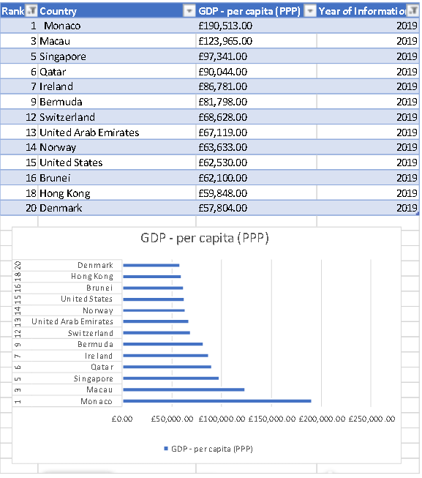

1. Colour the background by highlighting the area underneath the table as shown below. Find the add a fill colour icon and select a colour.

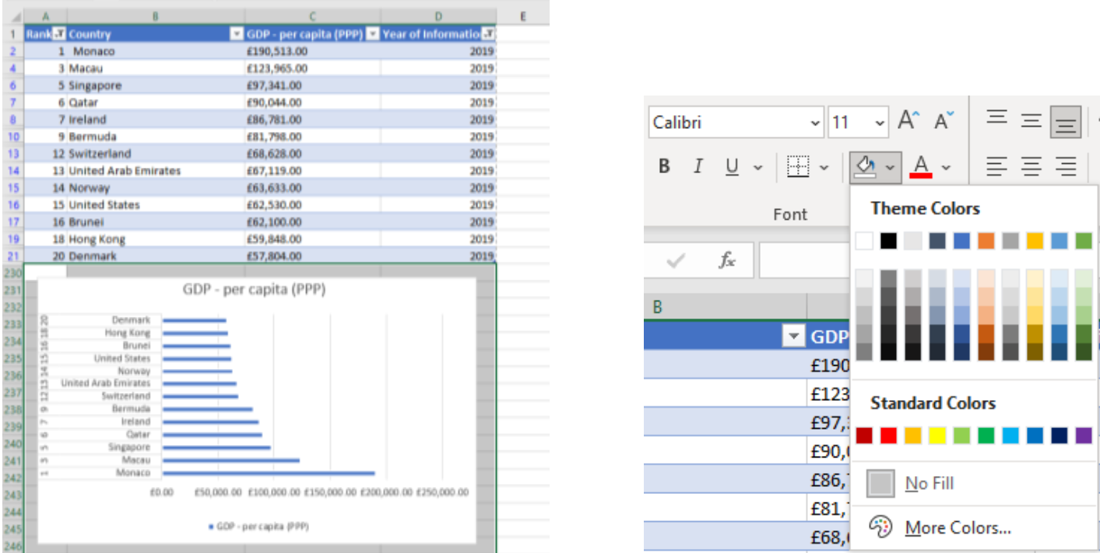

# First Task Answer (Day 1)

## Legislation

There are several laws governing ​the use of computing devices ​and the data they hold​. They are laws designed to protect users and their data from attack and misuse:​

## Computer Misuse Act 1990​

Accessing someone else’s computer or data without permission is an offence under the Computer Misuse Act​. This makes the following illegal:​

* Unauthorised access to computer material​
* Unauthorised access with intent to commit further offences​
* Unauthorised modification of computer material​

## Police and Justice Act 2006 (Computer Misuse)​

The major amendments to the Computer Misuse Act of 1990 were:​

* Making, owning or distributing hacking tools was made illegal if the person intends or believes it will be used for computer misuse​
* Denial of Service attacks were made illegal with a penalty of up to 10 years in jail​
* Denial-of-service attacks was made illegal. This was needed as the old law did not make clear whether DoS attacks were an offence.​

## Copyright, Designs and Patents Act 1988​

This Act is not specific to ​computer material​

* It gives the creators of literary, ​dramatic, musical and artistic works ​the right to control the ways in which ​their material may be used​
* It ensures that people are rewarded ​for their creative efforts​
* It gives them protection from people ​copying their work without permission

## The Copyright (Computer Programs) ​

These regulations updated the Copyright, Designs and Patent Act passed in1988​.The amendment made it clear that ​computer software was also subject ​to copyright​. It is illegal under this law to use ​copyrighted software without ​a licence​.

## The Health and Safety (Display Screen ​Equipment) Regulations 1992​

The main points are:​

* Employers must carry out a risk assessment of ​workstations used by employees to reduce risks​
* Employers must ensure that employees take ​regular breaks from looking at their screens​
* Employers must ensure that employees are ​aware of their entitlement to yearly eye tests, ​with the cost met by the employer​
* Employers must provide their computer users ​with health and safety training for any ​workstations that they use​

## Data Protection Act 2018​ (UK), GDPR (EU)

A new Data Protection Act (2018) replaced the Data Protection Act (1998) in May 2018. The new law enforces in the UK, the General Data Protection Regulation (GDPR), which came into force in Europe on 25 May 2018​. The law says that people have a right to privacy ​of personal data held on computer systems.

Any organisation must make sure ​that personal data is:​

* used fairly, lawfully and transparently​
* used for specified, explicit purposes​
* only used where necessary​
* accurate and kept up to date​
* kept for no longer than is necessary​
* handled in a secure way, including ​protection against unlawful or ​unauthorised processing, access, ​loss or damage​.

## Consumer Rights Act 2015​

Under this Act all products, whether digital or physical, must meet the following standards:​

* Satisfactory quality – not faulty or damaged (taking into account, for example, that bargain bucket products won’t be held to as high a standard as luxury goods)​
* Fit for purpose – for the purpose they are supplied for, or any purpose you made known to the shop when you bought them​
* As described – matching any description given to you or samples shown to you at the time of purchase​

# Second Task Answers (Day 1)

## Excel

### GDP Task 1

1. To protect a workbook with a password we need to go Review/Protect Workbook:

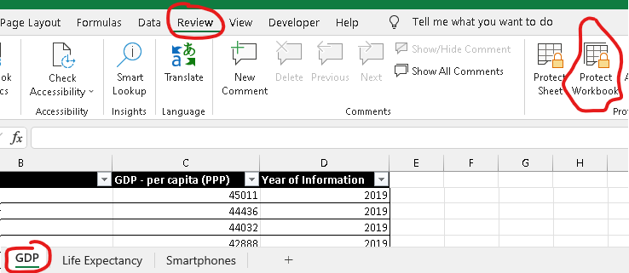

### GDP Task 2

1. To change General cell category into Currency with GBP we need to go to Home tab, then over to Number group and choose Currency:

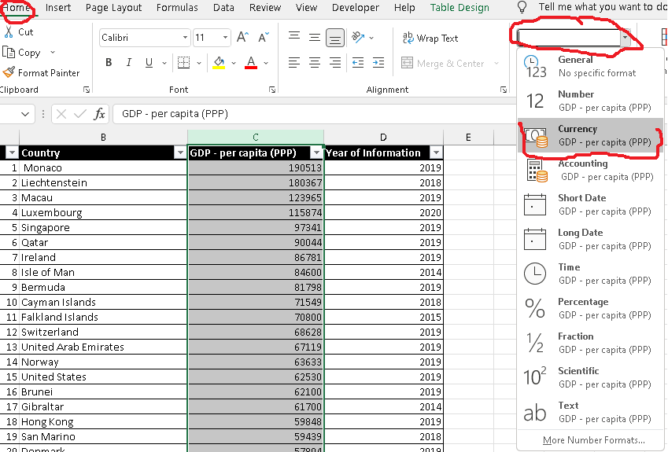

### GDP Task 3

1. 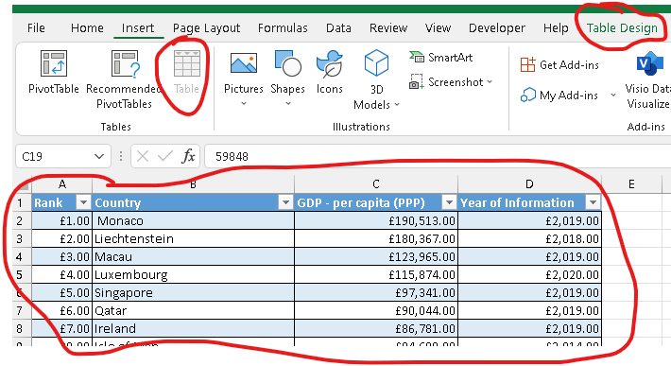Make any cell active within the dataset and highlight all by using Ctrl+A, then use Ctrl+T to convert it to a table:

### GDP Task 4

1. In “Year of Information” column, click the top arrow down and clear “Select All” to remove all years from the filter, then only mark 2019:

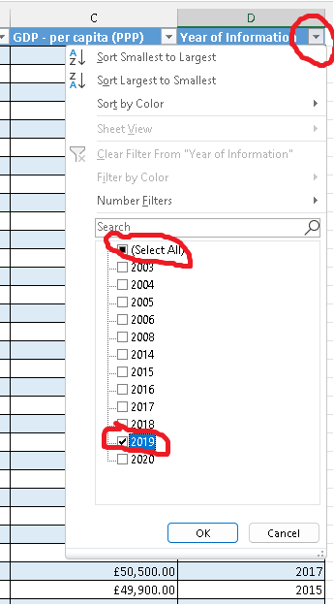

### GDP Task 5

1. 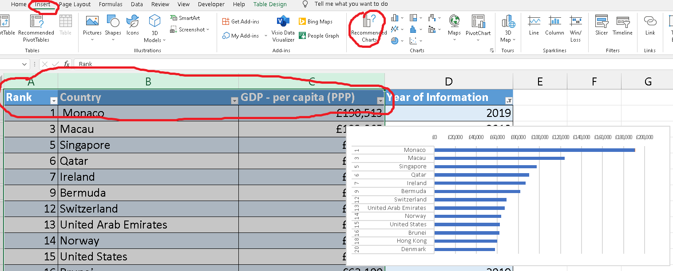To display a chart that will only display Rank, Country and GDP, we need to highlight these columns and then go to Ribbon “Insert” tab and then to group Charts choosing Recommended Charts:

### GDP Task 6

1. 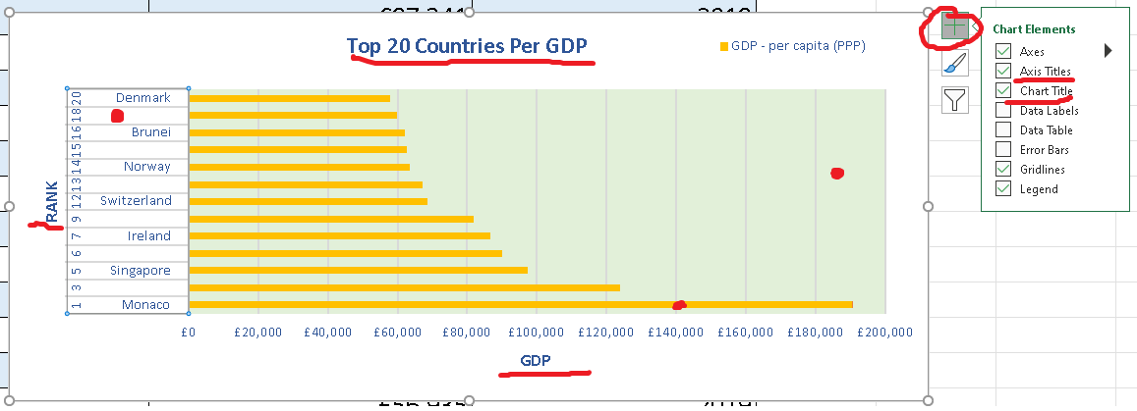To add a chart title and axis labels we need to click at “+” at the right top corner of the graph and then choose adequate options. To change colours, we need to click at each component separately (red dots below) and edit accordingly.

### GDP Task 7

1. 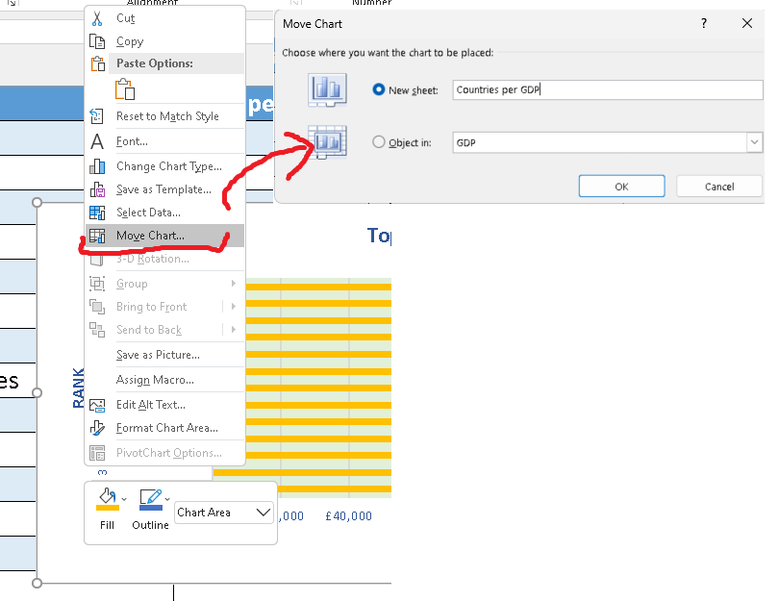To move a chart, we need to right click on the chart background around it and choose Move Chart, then New Sheet and give adequate name:

### GDP Task 8

1. Click at the filter in the right top corner and tick 20 top countries to show, as on the below screen capture.

### GDP Task 9

1. 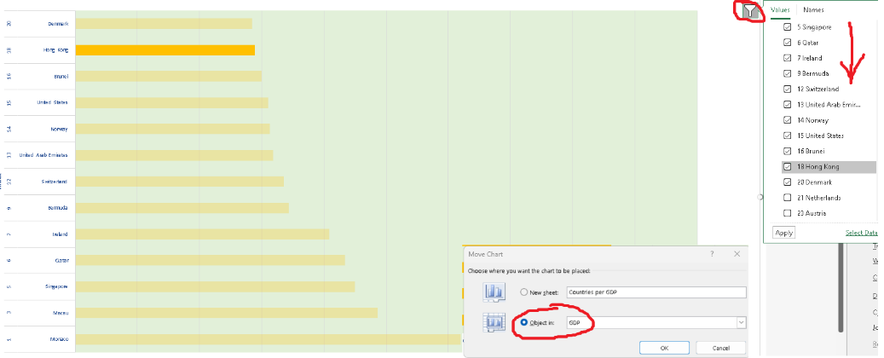Right click around the graph and choose “Move Chart…” then Object in GDP:

### GDP Task 10

1. To colour the background of the Chart, right click at it and choose Fill:

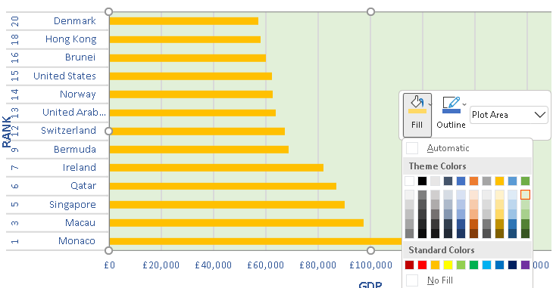

# Day 1 Assignment Conclusions and Reflections (Tasks 1 and 2)

Plotting graphs in Excel isn’t the most effective way of presenting data. As much as Excel has all the tools required for it, they aren’t user friendly at all. The whole process of transferring data to the graph and then improving its look to highlight key insights is very time consuming and more importantly hasn’t got the flexibility of solutions like Tableau or Power Bi.

Another very important aspect of data visualisations in excel that is missing is interaction with data. Filtering and sorting information on the go isn’t really possible to narrow the view or drill in to lower level of information without re-plotting the graph, or perhaps without the need of drawing multiple graphs. Excel data visualisation through graphs seems therefore very static poor in features.

We could potentially improve the capacity of Excel in this domain by using interactive dashboards or move to Power PivotCharts:

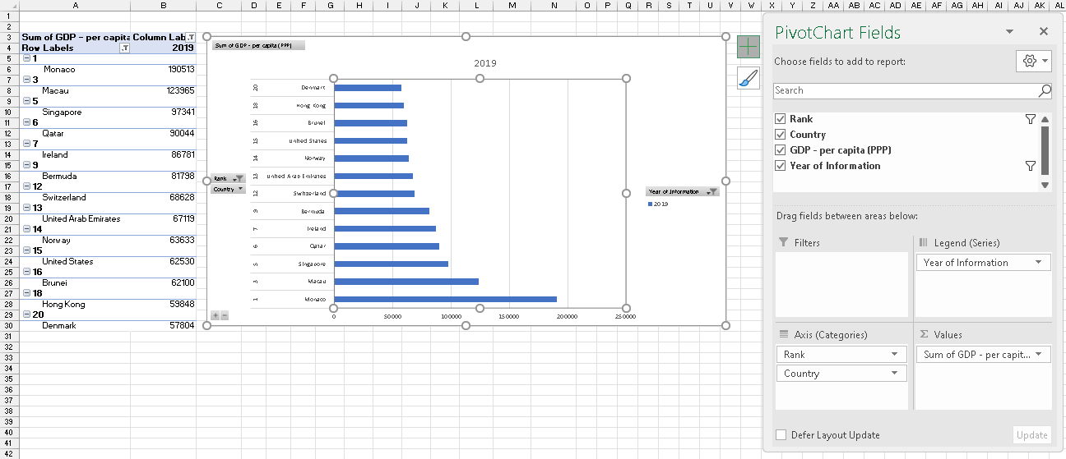

# Day 2 Answers

### Task 1

Here we first Insert 3 shapes as below and then add macros to them:

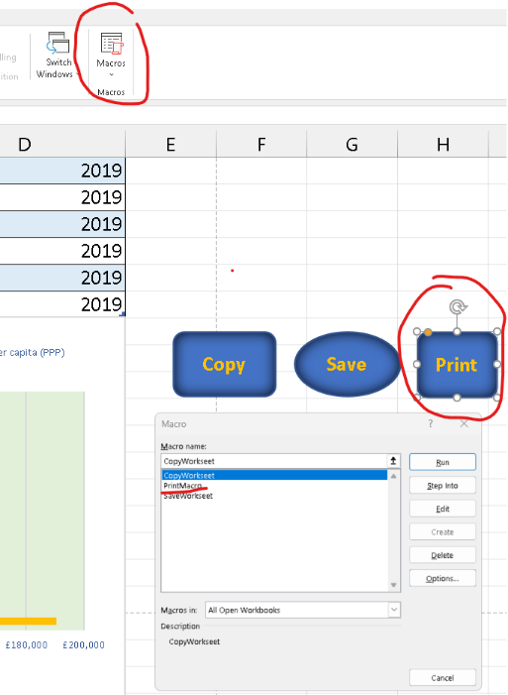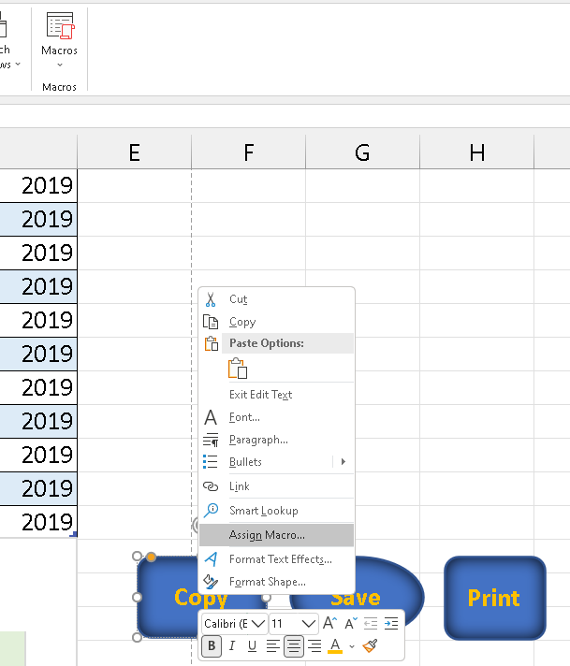

### Task 2

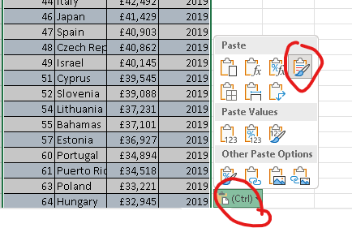To copy the sheet, we use the Copy button, and then insert a new worksheet at the bottom of tabs, then paste the content while choosing option Keep Source Formatting:

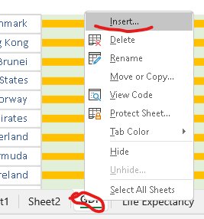

### Task 3

We need to go to File then Save us…:

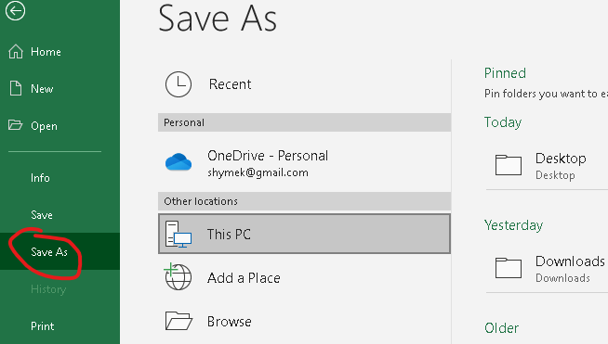

### Task 4

In this Task and the following two, I will just follow instructions from the assignment file.

### Task 5

Adding Header and Footer as instructed in the assignment file.

### Task 6

The following is the result of the steps from the assignment file:

### 

### Task 7

Returning to a normal view of the workbook:

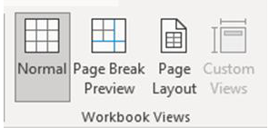

### Task 8

Saving as Excel Gross domestic product report 1



### Task 9

Closing document.

# Third Task Answers (Day 2)

## Tableau

### Task 1

Importing the file to Tableau:

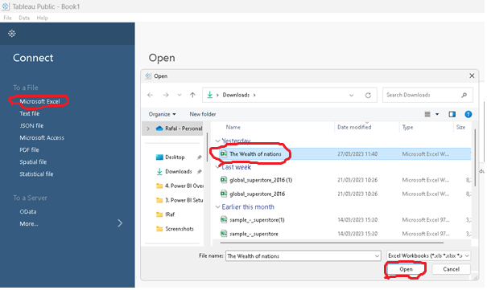

### Task 2

Setting up relationships between Life Expectancy, GDP and Smartphones sheets using Country Column:

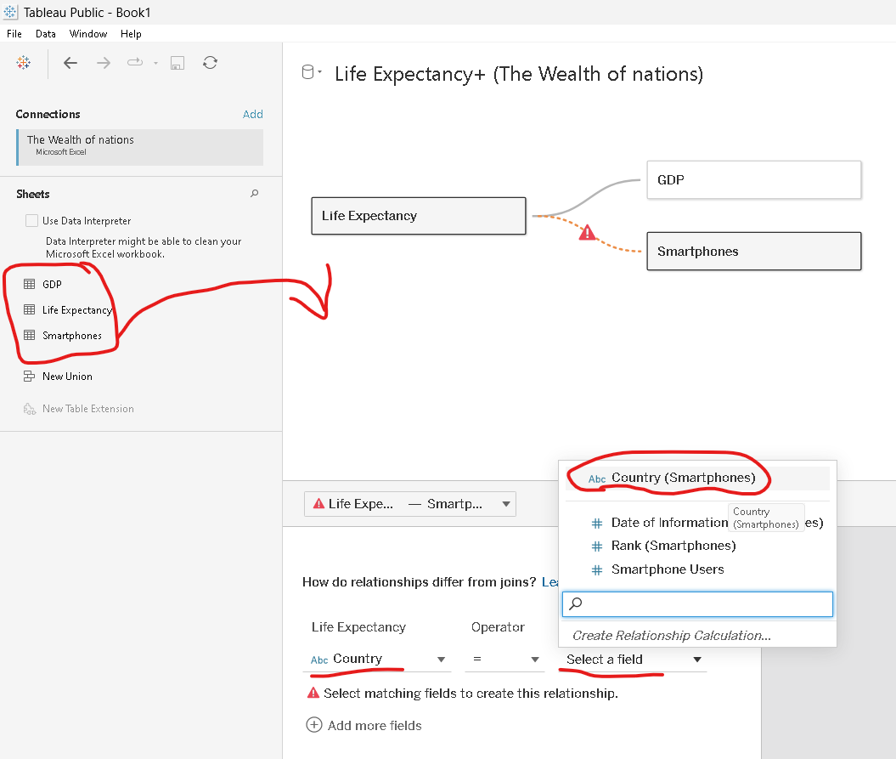

### Task 3

Before we start visualisations in Tableau we must check and correct all data types in our datasets just to ensure that Tableau assigned correct data types:

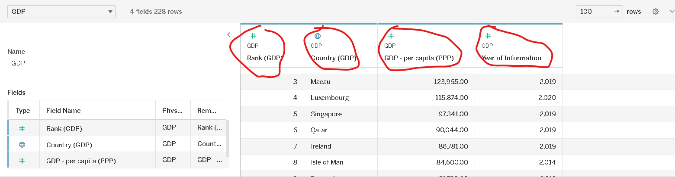

### Task 4

Graphs in Tableau:

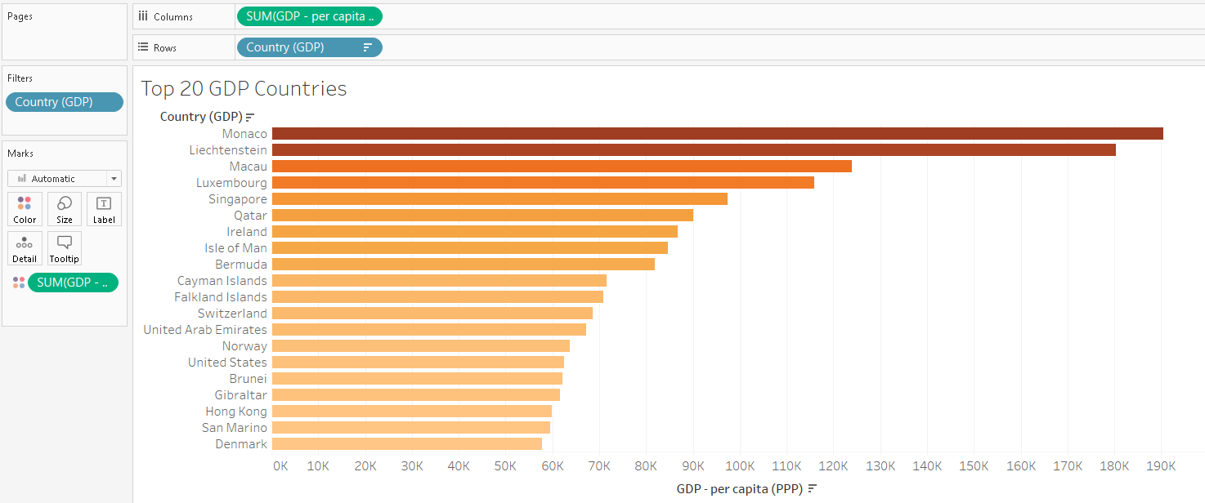

### Task 5

We need at least a few charts to create a dashboard to showcase our insights on data:

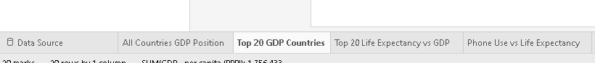

### Task 6

Finally, we can build a dashboard to present the data visually:

